2016 12 ATAR Psychology: How to set up your serial position effect lab report

Cover page / title: NO NEED TO INCLUDE IT, MARKS ARE NOT ALLOCATED FOR THEM.

Abstract:
⬧ The abstract is a short summary of the investigation.
Structure:
⬧ Write in past tense.
⬧ Cover the following information, in this order:
1. Why the study was done: aim of investigation (1 sentence).
2. Short description of participants and their characteristics (number of participants, gender, ages) (1-2 sentences).
3. Short description of procedure (what the participants did, how data was collected (1-2 sentences).
4. Short summary of results (1-2 sentences).
5. Statement claiming whether hypothesis was supported or not supported (e.g. The hypothesis that males were more active than females was supported….)
6. Short summary of the conclusion (1-2 sentences)
⬧ Use subheadings (background, method, results, conclusion) OR write in paragraph format without subheadings.
⬧ Recommended 150-word limit.

Introduction:
⬧ Write the introduction as if you don’t know the results yet.
Structure:
⬧ If you are describing existing results from research, write in the past tense, e.g. ‘Smith (1885) described several studies...’ If you are giving a general fact that is believed to be true, write in the present tense, e.g. ‘Recall is more difficult that recognition (Turner, 1975)’.
1. Explain background knowledge, start broad then move into more detail. For example, start by looking at what memory is, then look at short-term memory and finally focus on the serial position effect.
2. Describe previous work by others relevant to the topic (include citations).
3. State the operational hypothesis.
⬧ No ‘introduction’ heading.
⬧ Recommended 300-word limit.

Method:
⬧ The method must contain enough information for the reader to be able to repeat the study.
Structure:
⬧ Write the method in past tense.
⬧ It is written completely in sentences, no lists.
⬧ The method is broken into three sub-sections:
1. Participants: how many participants were tested, from what population they were drawn, how they were selected, their ages (age range, mean or median age), and composition in terms of males/females.
2. Materials: describe the materials used and how you devised them (or who devised them if you did not). ‘PowerPoint Presentation showing five sets of ten digits, provided by experimenter.’
3. Design: state the operationalised independent variable and operationalised dependent variable.
4. Procedure: describe what was done in time order.
⬧ Were participants tested individually or as a group?
⬧ Timing is important. Include how long participants were given to recall the information etc.
⬧ Give details of the testing location (quiet, well-lit room?)
⬧ Be sure to talk about anonymity relating to this experiment, how were participants kept anonymous?
⬧ Recommended 200-word limit.
Results:
1. Table: the title for a table goes above it. (Only put tables with collated/sorted data in the results section, a table with raw results goes in the appendices).

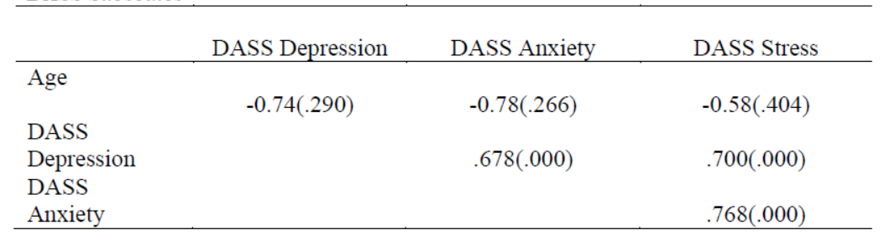
Table 1: Pearson Correlations and Significance Levels and the Three DASS Subscales.

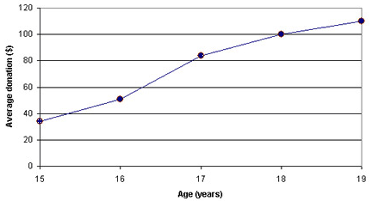
2. Graph: put the title of the graph below it, only graph the class average results.
Figure 1: Average number of dollars donated at Evergreen High School versus age of donor.

3. Write in words what the findings were, interpret any results but DON’T ANALYSE OR TRY TO EXPLAIN WHY THEY OCCURRED.
⬧ Refer to the table or graph in the text (e.g. the results summarised in Table 2 show that...).
⬧ Write in past tense.
⬧ Recommended 150-word limit.

Discussion:
1. Statement claiming whether hypothesis was supported or not supported (e.g. The hypothesis that males were more active than females was supported….)
2. Refer back to previous research (mentioned in introduction) and compare your results to theirs (explain any differences/similarities in the results, or anything in your results that you did not expect). Include citations.
3. Discuss uncontrolled variables: how the variable may have affected results, make suggestions on how to change study design or procedure to help improve the results next time.
4. Brief conclusion of what the study showed (1-2 sentences)
⬧ Recommended 400-word.
References:
⬧ All references should be cited according to the American Psychological Association (APA) format.
⬧ Write them in alphabetical order, first line is normal, any after are indented.

Appendices:
⬧ Start each appendix on a new page. (Appendix 1, Appendix 2 etc).

Presentation

⬧ Font in 12 point and Times New Roman.
⬧ 1.5 line spacing.
⬧ 3cm left and right page indentation.
⬧ Do not use justification of text. This is when the word processor forces lines of text to all be the same length. It makes the text look messy so don´t do it. Just have the text aligned to the left.
⬧ Do not use underlining, it looks messy. If you need to emphasize, italics is much better.
⬧ Include page numbers on the bottom of each page.
⬧ Start major sections (i.e. the Method, Results, and Discussion) on a new page.

Academic English usually uses:
⬧ Full forms, not contractions. So for example write is not instead of isn´t. Write cannot instead of can´t.
⬧ No slang or informal words, so for example write children instead of kids.
⬧ No sensational language, so write that the participants performed well, not that they performed fantastically.
⬧ Write in the third person, i.e. do not use ‘I’, ‘you’ or ‘we’. Use terms like the researcher and the participant.
⬧ Write in past tense, e.g. it was hypothesized; the researcher collected the data; the results showed.
⬧ Avoid talking about yourself. Don’t write ´I am going to discuss…´, just start discussing it. Don´t say
´we interviewed 20 participants´ say ´the researchers interviewed…´.
⬧ Language that is sensitive to race, disability, age etc. It is best to not use words describing nationalities, states of health etc. as nouns for people. So ´people with schizophrenia´ is better than ´schizophrenics´.
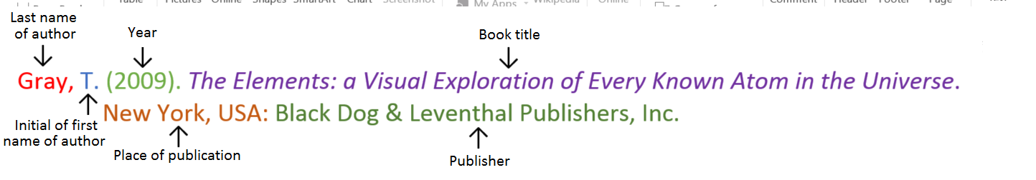
Book with two authors

Shermer, M., & Benjamin, A. (2006). Secrets of Mental Math: The Mathemagician’s Guide to Lightning Calculation and Amazing Mental Math Tricks. New York, USA: Three Rivers Press.

Book with three or more authors

Bulliet, R. W., Alley, R. B., Broecker, W. S., & Denton, G. H. (2011). The fate of Greenland: Lessons from abrupt climate change. Cambridge, MA: MIT Press.

Book with editor

Kasdorf, W. E. (Ed). (2003). The Columbia guide to digital publishing. New York, USA: Columbia University Press.

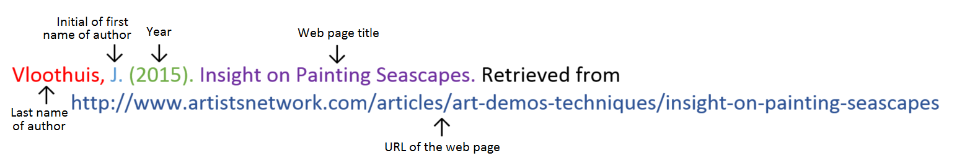
Website
Website with no author (put title of page at the front)

Aranmore Catholic College. (2014). Retrieved from http://www.aranmore.wa.edu.au/

Website with no date

The Zadkine Museum. (n.d). Retrieved http://www.france.fr/en/museums/zadkine-museum.html

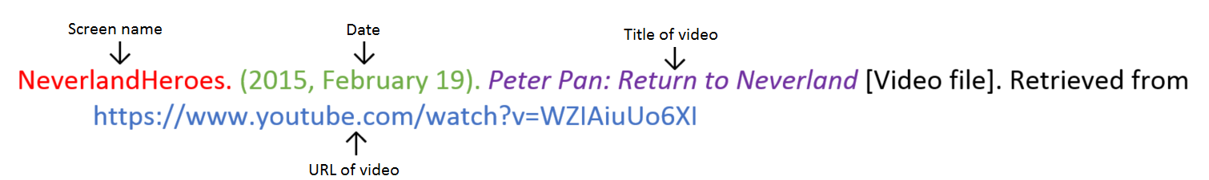
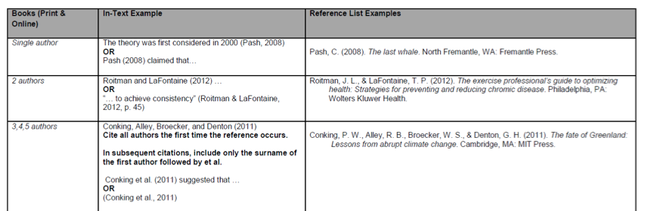
Video file
